PRODUCTION ANALYSIS AND CONTROLLING THROUGH I-NET

ABSTRACT

Food processing is the methods and techniques used to transform raw ingredients into food for human consumption. Food processing takes clean, harvested or slaughtered and butchered components and uses them to produce marketable food products. There are several different ways in which food can be produced, viz., one off production, batch production, mass production, just-in-time production. Food production reports are computerized to analyze the cost and units of ingredients purchased month on month or on daily basis and to analyze the production of food materials. But such computerized applications cannot be accessed wherever or whenever required. This is a web-based application that deals with the production of food in a food processing company where the raw products are taken into account, processed, packed and sent to the sales department. The system also keeps an account of those raw materials, consumption of stock, stock available, progress of the work done and comparison of the work done on a monthly basis.

INTRODUCTION

PROJECT DESCRIPTION

This project titled ‘Production Analysis and Controlling through Internet’ is a web-based application which is for use by a food production company. The system can be accessed by the production manager and the workers of the company from anywhere and anytime and know the process being carried out.
Whenever the manager log into his account for the first time everyday, he has to set the target for the day by selecting the item name and specifying the number of food packets to be produced within the day.
The manager can enter the stock which is purchased for the company using the link ‘Purchase Entry’. This purchase entry can be done for stock purchased on both monthly and daily basis. Purchase entry requires the raw material which is purchased, number of units purchased, and the rate of the raw material per unit. This purchase detail gets stored up in the database with the date of purchase and the stock is increased.
The manager can choose a particular category and view the current stock each raw material available.
The manager enters the amount of food packets processed and ready for sending it to the sales department under stock consumed. When the amount of food packets is entered, the stock gets reduced.
Working Progress of the day can be viewed by the manager and all workers of the company which displays the amount of food packets set as target, number of food packets completed, the remaining number of packets to be produced and the status of production for each food item.
The Monthly Projection is a comparison of monthly purchase or daily purchase or production for two months. The comparison is depicted in the form of a bar graph. The option and the months for comparing are chosen by the user. Both the manager and the workers of the company can view this comparison. The graph can be saved to the user’s system if required.

SYSTEM STUDY

EXISTING SYSTEM

Food production analysis systems are stand-alone system which cannot be accessed wherever and whenever required. Comparison of purchase reports and production reports are only exported to Office applications which also has a strong disadvantage of accessibility issues. Such food production analysis and controlling application packages are costly and need to be purchased wherein the cost involved in developing these application packages are high.

PROPOSED SYSTEM

This project provides a web-based Production analysis and controlling application which ensures access of information whenever and wherever required. Comparing the purchase and production between two months can be done for which the comparison results are displayed on the browser window as graphical charts, which provides accessibility of the comparison report easier. Since this web-based application is completely programmed in PHP and uses WAMP server as the web server all which are open-source packages, cost involved in development of the application is lesser compared to that of stand-alone packages.

SYSTEM CONFIGURATION

HARDWARE REQUIREMENTS

RAM : 256 MB
HDD : 80 GB

SOFTWARE REQUIREMENTS

Operating System : Windows XP
Web Server : WAMP/LAMP/XAMP
Server side scripting Language : PHP 5.0
Database : MYSQL
Web Browser : IE 7.0/Fire Fox/Netscape Navigator
Client side scripting Language : JavaScript

SYSTEM DESIGN - USE CASE DIAGRAM

Login
Purchase Entry
Stock-in-hand
Stock consumed
Stock consumed
Working Progress
Monthly Projection
Reports
Manager
Workers
System
Set Target for the day
DATA FLOW DIAGRAM - Manager

Login
Password
Working Progress
Stock-in-hand
Stock consumed
Purchase Entry
Monthly Projection
Reports
Category, Item name, Quantity, Rate per unit
Store purchase details
Category
Retrieve item name, quantity by given category
Item name & no. of packets produced
Update stock and product details if stock available, else report error
Set Target
Item name & no. of packets
Item name
Retrieve the target set, no. of packets completed by item name
Months and category for which graph has to be displayed
Retrieve the items by category & month, display graph
Date for which report has to be generated
Retrieve purchase details & amount by date
Store item name & no. of packets in db
DATA FLOW DIAGRAM – Workers

Working progress
Monthly projection
Worker’s page
Item name
Retrieve the target set, no. of packets completed by item name
Months and category for which graph has to be displayed
Retrieve the items by category & month, display graph

ACTIVITY DIAGRAM

Start
Login
Workers
Manager
Password correct
Yes
No
Item name for working progress
No. of packets - set as target, completed, yet to go
Stop
Monthly Projection
Months and category

Draw graph
Category, Item name, Quantity, Rate per unit

Purchase Entry
Category to see Stock-in-hand
Display Items under category and no. of units available
Item name, no. of packets produced
Stock consumed
Date for which report has to be generated
Display purchase details and amount by date
DATABASE DESIGN

Name of the Database: Ben
No.of Tables: 8
Table Name: consume

Field | Type | Null | Default
id | int(11) | Yes | NULL
prod_name | varchar(75) | Yes | NULL
quantity | int(11) | Yes | NULL
dat | date | Yes | NULL

Table Name: ingredients
Field | Type | Null | Default
prod_id | int(11) | Yes | NULL
ingredient_id | bigint(20) | Yes | NULL
quantity | int(11) | Yes | NULL

Table Name: itemlist
Field | Type | Null | Default
items | varchar(25) | Yes | NULL
category | varchar(25) | Yes | NULL

Table Name: login
Field | Type | Null | Default
password | varchar(10) | Yes | NULL
dat | date | Yes | NULL

Table Name: productlist
Field | Type | Null | Default
prod_id | int(11) | Yes | NULL
prod_name | varchar(50) | Yes | NULL
target | int(11) | Yes | NULL

Table Name: purchase_daily

Field | Type | Null | Default
purchase_id | int(11) | Yes | NULL
item_name | varchar(50) | Yes | NULL
quantity | bigint(20) | Yes | NULL
units | varchar(10) | Yes | NULL
rate | float | Yes | NULL
amount | float | Yes | NULL
category | varchar(50) | Yes | NULL
purchase_date | varchar(15) | Yes | NULL

Table Name: purchase_monthly

Field | Type | Null | Default
purchase_id | int(11) | Yes | NULL
item_name | varchar(50) | Yes | NULL
quantity | bigint(20) | Yes | NULL
units | varchar(10) | Yes | NULL
rate | float | Yes | NULL
amount | float | Yes | NULL
category | varchar(40) | Yes | NULL
purchase_date | varchar(15) | Yes | NULL

Table Name: stock

Field | Type | Null | Default
id | bigint(20) | Yes | NULL
item_name | varchar(50) | Yes | NULL
category | varchar(50) | Yes | NULL
quantity | bigint(20) | Yes | NULL

SOFTWARE PROFILE

WAMP Server

WAMPs are packages of independently-created programs installed on computers that use a Microsoft Windows operating system. The interaction of these programs enables dynamic web pages to be served over a computer network, such as the internet or a private network. The equivalent installation on a Linux operating system is known as LAMP. The equivalent installation on a Mac operating system is known as MAMP. The equivalent installation on a Solaris operating system is known as SAMP. The equivalent installation on a FreeBSD operating system is known as FAMP.

"WAMP" is an acronym formed from the initials of the operating system (Windows) and the package's principal components: Apache, MySQL and PHP (or Perl or Python).
- Apache is a web server, which allows people with web browsers like Internet Explorer or Firefox to connect to a computer and see information there as web pages.
- MySQL is a database manager (that is, it keeps track of data in a highly organized way).
- PHP is a scripting language which can manipulate information held in a database and generate web pages afresh each time an element of content is requested from a browser.

Apache

The Apache HTTP Server, commonly referred to simply as Apache is a web server notable for playing a key role in the initial growth of the World Wide Web. The majority of all web servers using Apache are Linux web servers.
Apache is developed and maintained by an open community of developers under the auspices of the Apache Software Foundation. The application is available for a wide variety of operating systems, including UNIX, FreeBSD, Linux, Solaris, Novell NetWare, Mac OS X, Microsoft Windows, OS/2, TPF, and eComStation. Released under the Apache License, Apache is characterized as free software and open source software.

Apache is primarily used to serve both static content and dynamic Web pages on the World Wide Web. Many web applications are designed expecting the environment and features that Apache provides. Apache is the web server component of the popular LAMP web server application stack, alongside MySQL, and the PHP/Perl/Python (and now also Ruby) programming languages.
Apache is redistributed as part of various proprietary software packages including the Oracle Database or the IBM WebSphere application server. Mac OS X integrates Apache as its built-in web server and as support for its WebObjects application server. It is also supported in some way by Borland in the Kylix and Delphi development tools. Apache is included with Novell NetWare 6.5, where it is the default web server. Apache is also included with many Linux distributions.
Apache is used for many other tasks where content needs to be made available in a secure and reliable way. One example is sharing files from a personal computer over the Internet. A user who has Apache installed on their desktop can put arbitrary files in the Apache's document root which can then be shared.
Programmers developing web applications often use a locally installed version of Apache in order to preview and test code as it is being developed.
Microsoft Internet Information Services (IIS) is the main competitor to Apache, trailed by Sun Microsystems' Sun Java System Web Server and a host of other applications such as Zeus Web Server. Some of the biggest web sites in the world are run using Apache. Google's search engine front end is based on a modified version of Apache, named Google Web Server (GWS).
MySQL
MySQL is a relational database management system (RDBMS) which has more than 11 million installations. The program runs as a server providing multi-user access to a number of databases.
MySQL is owned and sponsored by a single for-profit firm, the Swedish company MySQL AB, now a subsidiary of Sun Microsystems, which holds the copyright to most of the codebase. The project's source code is available under terms of the GNU General Public License, as well as under a variety of proprietary agreements.
MySQL is popular for web applications and acts as the database component of the LAMP, BAMP, MAMP, SAMP, and WAMP platforms and for open-source bug tracking tools like Bugzilla. Its popularity for use with web applications is closely tied to the popularity of PHP, which is often combined with MySQL. Several high-traffic web sites (including Flickr, Facebook, Wikipedia, Google, Nokia and YouTube) use MySQL for its data storage and logging of user data.

PHP

PHP stands for PHP: Hypertext Preprocessor. Hypertext refers to files linked together using hyperlinks, such as HTML (HyperText Markup Language) files. Preprocessing is executing instructions that modify the output.
PHP is a scripting language originally designed for producing dynamic web pages. It has evolved to include a command line interface capability and can be used in standalone graphical applications. PHP is free software released under the PHP License, however it is incompatible with the GNU General Public License (GPL), due to restrictions on the usage of the term PHP.
PHP is a widely-used general-purpose scripting language that is especially suited for web development and can be embedded into HTML. It generally runs on a web server, taking PHP code as its input and creating web pages as output. It can be deployed on most web servers and on almost every operating system and platform free of charge. PHP is installed on more than 20 million websites and 1 million web servers.
PHP 5 was released in July 2004 after long development and several pre-releases. It is mainly driven by its core, the Zend Engine 2.0 with a new object model and dozens of other new features.

Demonstration of the difference between HTML and PHP files.
- Accessing an HTML Page
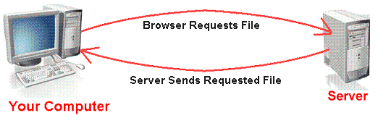
  - Your browser sends a request to that web page's server (computer) for the file (HTML or image) you wish to view.
  - The web server (computer) sends the file requested back to your computer.
  - Your browser displays the file appropriately.
- Accessing a PHP Page
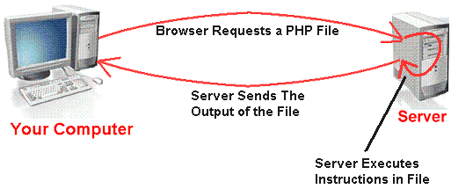
  - Your browser sends a request to that web page's server for the PHP file you wish to view.
  - The web server calls PHP to interpret and perform the operations called for in the PHP script.
  - The web server sends the output of the PHP program back to your computer.
  - Your browser displays the output appropriately.
HTML

HTML, an initialism of HyperText Markup Language, is the predominant markup language for Web pages. It provides a means to describe the structure of text-based information in a document—by denoting certain text as links, headings, paragraphs, lists, and so on—and to supplement that text with interactive forms, embedded images, and other objects. HTML is written in the form of tags, surrounded by angle brackets. HTML can also describe, to some degree, the appearance and semantics of a document, and can include embedded scripting language code (such as JavaScript) which can affect the behavior of Web browsers and other HTML processors.
JAVASCRIPT
JavaScript is a scripting language widely used for client-side web development. It was the originating dialect of the ECMAScript standard. It is a dynamic, weakly typed, prototype-based language with first-class functions. JavaScript was influenced by many languages and was designed to look like Java, but be easier for non-programmers to work with. Although best known for its use in websites (as client-side JavaScript), JavaScript is also used to enable scripting access to objects embedded in other applications.
JavaScript, despite the name, is essentially unrelated to the Java programming language, although both have the common C syntax, and JavaScript copies many Java names and naming conventions. The language's name is the result of a co-marketing deal between Netscape and Sun, in exchange for Netscape bundling Sun's Java runtime with their then-dominant browser. The key design principles within JavaScript are inherited from the self and Scheme programming languages. "JavaScript" is a trademark of Sun Microsystems. It was used under license for technology invented and implemented by Netscape Communications and current entities such as the Mozilla Foundation.
The primary use of JavaScript is to write functions that are embedded in or included from HTML pages and interact with the Document Object Model (DOM) of the page. Some simple examples of this usage are:
- Opening or popping up a new window with programmatic control over the size, position, and attributes of the new window (i.e. whether the menus, toolbars, etc. are visible).
- Validation of web form input values to make sure that they will be accepted before they are submitted to the server.
- Changing images as the mouse cursor moves over them: This effect is often used to draw the user's attention to important links displayed as graphical elements.
Because JavaScript code can run locally in a user's browser (rather than on a remote server) it can respond to user actions quickly, making an application feel more responsive. Furthermore, JavaScript code can detect user actions which HTML alone cannot, such as individual keystrokes.

IMPLEMENTATION AND TESTING
IMPLEMENTATION
List of modules in the project
- Purchase Entry
- Stock-in-hand
- Stock consumed
- Working Progress
- Monthly Projection
- Report
MODULE DESCRIPTION
Purchase Entry
This module deals with the information about the raw materials purchased for the production of food in the company. The materials are stored category wise. Separate entries are to be made for the monthly and daily requirements.
Stock-in-hand
The input to this module is the category of raw materials. This module displays the list of raw materials under the given category and the stock currently available. The manager alone has the authority to view the list of raw materials available
Stock Consumed:
This module deals with the raw materials consumed in processing of food materials and shows the amount of items consumed for every food material. As the production of food materials are entered, their ingredients are reduced from the stock purchased in monthly as well as in daily basis. It also shows the demand for any raw material which is used to produce the food material. The manager enters the number of packets completed which is detected form the target set for the day.
Working Progress:
The working progress module shows amount of packets completed, number of packets yet more to be produced and if it’s an underproduction or over production. Both manager and workers can view the progress of production of food materials.
Monthly Projection:
The monthly projection deals with graph. It shows the comparison of purchase/production between two months. We can compare the purchase details in the basis of monthly and daily. The graph is a bar graph. In purchase, the ingredients come in x-axis and units come in y-axis. If it is production the name of the food materials are displayed in the x-axis and the number of food packets comes in the y-axis. The workers and the manager can compare the purchase/production between two months.
Report:
The report is generated on the items purchased and the amount spent for the purchase.

TESTING
Definition of Software Testing:
Software testing an activity being part of the software development process aimed at evaluating a software item (system, subsystem, unit etc.) features (functionality, performance etc.) against the given set of system requirements.
Software testing implies running the software item in predetermined conditions (test case, test scenario), recording and analyzing the obtained results, and identifying errors (i.e. bugs), which means failure to satisfy a set of requirements to the software.
Testing is a process used to help identify the correctness, completeness and quality of developed computer software. With that in mind, testing can never completely establish the correctness of computer software.
Software Testing Fundamentals:
- Testing objectives
Testing is a process of executing a program with the intent of finding an error.
A good test case is one that has a high probability of finding an as yet undiscovered error. A successful test is one that uncovers an as yet undiscovered error.
Testing should systematically uncover different classes of errors in a minimum amount of time and with a minimum amount of effort. A secondary benefit of testing is that it demonstrates that the software appears to be working as stated in the specifications. The data collected through testing can also provide an indication of the software's reliability and quality. But, testing cannot show the absence of defect -- it can only show that software defects are present.
  - Testing start process
Testing early in the life cycle reduces the errors. Test deliverables are associated with every phase of development. The goal of Software Tester is to find bugs, find them as early as possible, and make them sure they are fixed. The number one cause of Software bugs is the Specification. There are several reasons specifications are the largest bug producer.
Risk Identification:
1. Software Risks: Knowledge of the most common risks associated with Software development, and the platform you are working on.
2. Business Risks: Most common risks associated with the business using the Software
3. Testing Risks: Knowledge of the most common risks associated with Software Testing for the platform you are working on, tools being used, and test methods being applied.
4. Premature Release Risk: Ability to determine the risk associated with releasing unsatisfactory or untested Software Products.
5. Risk Methods: Strategies and approaches for identifying risks or problems associated with implementing and operating information technology, products and process; assessing their likelihood, and initiating strategies to test those risks.
White Box Testing:
For doing this testing process the person have to access to the source code of the product to be tested. So it is essential that the person doing this white box testing have some knowledge of the program being tested. Though not necessary it would be more worth if the programmer itself does this white box testing process since this testing process requires the handling of source code.
Black Box Testing:
This is otherwise called as functional testing. In contrary to white box testing here the person who is doing the black box testing need not have the programming knowledge. This is because the person doing the black box testing would access the output or outcomes as the end user would access and would perform thorough functionality testing to check whether the developed module or product behaves in functionality in the way it has to be.
Compatibility testing:
Compatibility testing part of software non-functional tests, is testing conducted on the application to evaluate the application's compatibility with the computing environment. Computing environment may contain some or all of the below mentioned elements:
- Computing capacity of Hardware Platform (IBM 360, HP 9000, etc.)
- Bandwidth handling capacity of networking hardware
- Compatibility of peripherals (Printer, DVD drive, etc.)
- Operating systems (MVS, UNIX, Windows, etc.)
- Database (Oracle, Sybase, DB2, etc.)
- Other System Software (Web server, networking/ messaging tool, etc.)
- Browser compatibility (Firefox, Netscape, Internet Explorer, Safari, etc.)
- Carrier compatibility (Verizon, Sprint, Orange, O2, AirTel, etc.)
Usability testing:
Usability testing is a technique used to evaluate a product by testing it on users. This can be seen as an irreplaceable usability practice, since it gives direct input on how real users use the system. This is in contrast with usability inspection methods where experts use different methods to evaluate a user interface without involving users.
Usability testing focuses on measuring a human-made product's capacity to meet its intended purpose. Examples of products that commonly benefit from usability testing are web sites or web applications, computer interfaces, documents, or devices. Usability testing measures the usability, or ease of use, of a specific object or set of objects, whereas general human-computer interaction studies attempt to formulate universal principles.
User Acceptance Testing (UAT):
User acceptance testing is the most critical level of testing because it is the final opportunity to identify any problems before the solution is implemented. In addition, this testing concludes with signed off acceptance of the solution by the client. User acceptance testing must be conducted thoroughly and accurately to give the final assurance of quality and checking that the solution meets the business requirements.
User acceptance testing is the process of:
- Confirming that the solution performs according to specification.
- Finding and fixing errors until the acceptance criteria are met.
The testing must ensure that the solution will perform as expected when implemented. To achieve this, testers are advised not only to verify that the solution works, but also to focus on finding errors. Only when they can no longer find errors can they be confident that the solution will function correctly and as expected.
Before commencing user acceptance testing make sure that the acceptance criteria have been defined. User acceptance testing continues until the acceptance criteria are met and the project owner/sponsor signs off that the solution is ready for implementation. In user acceptance testing the users execute the user acceptance test cases prepared by the business analyst in the design phase of the project according to the testing strategy.

CONCLUSION

Since this is a web-based application, food production analysis is done easily from anywhere and anytime by the manager. Comparison of both purchase and production for months will also contribute in the decision-making process. The result of comparison is also displayed as a pictorial bar graph which is easily understandable. The current stock available can be viewed by category. Warning messages are displayed in case of stock unavailability during stock consumption which ensures proper stock maintenance. On the whole, this is a very efficient system with high performance and great utility.

BIBLIOGRAPHY

- http://www.sunilb.com/php/php-tutorials/php5-oops-tutorial-learn-to-create-a-php5-class
- http://www.ibm.com/developerworks/library/x-xmlphp2.html
- http://www.wikipedia.org
- http://www.php.net
- http://www.dev.mysql.com
- http://www.mysql.com
- http://www.w3schools.com
- http://phplot.sourceforge.net/phplotdocs/

SOURCE CODE

Login.php

<?php
session_start();
?>
<!DOCTYPE html PUBLIC "-//W3C//DTD XHTML 1.0 Transitional//EN" "http://www.w3.org/TR/xhtml1/DTD/xhtml1-transitional.dtd">
<html xmlns="http://www.w3.org/1999/xhtml">
<head>
<meta http-equiv="Content-Type" content="text/html; charset=iso-8859-1" />
<script type="text/javascript" language="javascript">
function valid()
{
if(document.form1.manpass.value == "")
{
alert("Enter the password");
document.form1.manpass.focus();
return false;
}
return true;
}
</script>
<title>Untitled Document</title>
<style type="text/css">
<!--
th
{
font-family: georgia;
color:#0066FF;
text-decoration:none;
}
td
{
font-family: georgia;
color:#0066FF;
text-decoration:none;
}
a
{
font-family: cursive;
color:#007700;
text-decoration:none;
}
a:hover
{
font-family: cursive;
color:red;
text-decoration:underline;
}
input
{
background-image:url(benito/bg201.gif);
border-color:#0000FF;
color:#3333FF;
font-family:Georgia;
font-weight:bold;
border-style:groove;
}
select
{
background-image:url(benito/bg201.gif);
border-color:#0000FF;
color:#3333FF;
font-family:Georgia;
font-weight:bold;
border-style:groove;
}
.style1 {font-size: 24px}
.style2 {font-size: 16px}
-->
</style></head>
<body background="benito/bg201.gif">
<?php
include("dbcon.php");
extract($_POST);
$datt = date("Y-m-d");
if(isset($plog))
{
$p1= "select * from login where password = '$manpass'";
$p2 = mysql_query($p1);
$n = mysql_fetch_array($p2);
if($n['password'] == $manpass)
{
$_SESSION['user'] = 1;
if($n['dat'] != $datt)
{
mysql_query("update login set dat = '$datt'");
mysql_query("update productlist set target = '0'");
header("Location: target.php");
}
elseif($n['dat'] == $datt)
{
header("Location: left.php");
}
}
else
{
$msg = "Incorrect Password";
}
}
else
$msg = "You are requested to enter the password";
?>
<form id="form1" name="form1" method="post" action="">
<div align="center">
<p>&nbsp;</p>
<table width="455" height="177" border="1" cellpadding="0" cellspacing="0" bordercolor="#0033FF">
<tr>
<th width="425" scope="col"><table width="424" height="156" border="0" cellpadding="0" cellspacing="0">

<tr>
<td height="41" colspan="2" align="center"><span class="style1">MANAGER'S LOGIN</span></td>
</tr>
<tr>
<td height="41" colspan="2" align="center"><?php echo $msg;?></td>
</tr>
<tr>
<td width="240" height="41" align="center">MANAGER'S PASSWORD</td>
<td width="183" align="center"><label>
<input name="manpass" type="password" id="manpass" />
</label></td>
</tr>
<tr>
<td height="33" colspan="2"><p align="center">
<label>
<input name="plog" type="submit" id="plog" value="LOGIN" onclick = "return valid()"/>
</label>
</p></td>
</tr>
</table></th>
</tr>
</table>
<p>&nbsp;</p>
<p>&nbsp;</p>
</div>
</form>
</body>
</html>

target.php

<?php
session_start();
?>
<!DOCTYPE html PUBLIC "-//W3C//DTD XHTML 1.0 Frameset//EN" "http://www.w3.org/TR/xhtml1/DTD/xhtml1-frameset.dtd">
<html xmlns="http://www.w3.org/1999/xhtml">
<head>
<meta http-equiv="Content-Type" content="text/html; charset=iso-8859-1" />
<title>Untitled Document</title>
</head>

<frameset rows="*" cols="195,*" framespacing="0" frameborder="no" border="0">
<frame src="itemlist1.php" name="frame1" scrolling="auto" noresize="noresize" id="leftFrame" title="leftFrame" />
<frame src="blank.php" name="frame3" id="frame3" title="mainFrame" />
</frameset>
<noframes><body>
</body>
</noframes></html>

Disp_progress.php

<?php
session_start();
$con = mysql_connect("localhost","root","") or die("Could not connect");
mysql_select_db("ben");
$id = $_GET['prodid'];
$sql = mysql_query("select * from productlist where prod_id = '$id'");
$row = mysql_fetch_array($sql);
$prodname = $row['prod_name'];
$datt = date("Y-m-d");
$sql1 = mysql_query("select * from consume where prod_name = '$prodname' and dat = '$datt'");
$row1 = mysql_fetch_array($sql1);
$produce = $row['target'] - $row1['quantity'];

?>
<!DOCTYPE html PUBLIC "-//W3C//DTD XHTML 1.0 Transitional//EN" "http://www.w3.org/TR/xhtml1/DTD/xhtml1-transitional.dtd">
<html xmlns="http://www.w3.org/1999/xhtml">
<head>
<style>
th
{
font-family: georgia;
color:#0066FF;
text-decoration:none;
}
td
{
font-family: georgia;
color:#0066FF;
text-decoration:none;
}
input
{
background-image:url(benito/bg201.gif);
border-color:#0000FF;
color:#3333FF;
font-family:Georgia;
font-weight:bold;
border-style:groove;
}
select
{
background-image:url(benito/bg201.gif);
border-color:#0000FF;
color:#3333FF;
font-family:Georgia;
font-weight:bold;
border-style:groove;
}
a
{
font-family: cursive;
color:#0033FF;
text-decoration:none;
}
a:hover
{
font-family: cursive;
color:red;
text-decoration:underline;
}

</style>

<meta http-equiv="Content-Type" content="text/html; charset=iso-8859-1" />
<title>Untitled Document</title>
</head>

<body background="benito/bg201.gif">
<form id="form1" name="form1" method="post" action="">
<table width="394" border="1" align="center" cellpadding="0" cellspacing="0" bordercolor="#0033FF">
<tr>
<th width="390" scope="col"><table width="385" border="0" align="center" cellpadding="2" cellspacing="2">
<tr>
<th height="27" colspan="2" scope="row"><?php echo $row['prod_name'];?></th>
</tr>
<tr>
<th colspan="2" scope="row"> <?php if($produce < 0)
{
echo "There is an over-production";
}
elseif($produce > 0)
{
echo "There is an under-production";
}
else
{
echo "Production completed";
}
?></th>
</tr>
<tr>
<th width="226" scope="row">Target Set </th>
<td width="225" align="center"><?php echo $row['target'];?></td>
</tr>
<tr>
<th scope="row">Completed</th>
<td align="center"><?php echo $row1['quantity'];?></td>
</tr>
<tr>
<th scope="row">Yet to go </th>
<td align="center"><?php echo $produce;?></td>
</tr>
</table></th>
</tr>
</table>
<p>&nbsp;</p>
</form>
</body>
</html>

Disp_selected.php

<?php
session_start();
$con = mysql_connect("localhost","root","") or die("Could not connect");
mysql_select_db("ben");
$sql = mysql_query("select * from productlist where target != '0'");
?>
<!DOCTYPE html PUBLIC "-//W3C//DTD XHTML 1.0 Transitional//EN" "http://www.w3.org/TR/xhtml1/DTD/xhtml1-transitional.dtd">
<html xmlns="http://www.w3.org/1999/xhtml">
<head>
<strong>
<style>
th
{
font-family: georgia;
color:#0066FF;
text-decoration:none;
}
input
{
background-image:url(benito/bg201.gif);
border-color:#0000FF;
color:#3333FF;
font-family:Georgia;
font-weight:bold;
border-style:groove;
}
select
{
background-image:url(benito/bg201.gif);
border-color:#0000FF;
color:#3333FF;
font-family:Georgia;
font-weight:bold;
border-style:groove;
}
td
{
font-family: georgia;
color:#0066FF;
text-decoration:none;
}
a
{
font-family: cursive;
color:#0033FF;
text-decoration:none;
}
a:hover
{
font-family: cursive;
color:red;
text-decoration:underline;
}

</style>
</strong>
<meta http-equiv="Content-Type" content="text/html; charset=iso-8859-1" />
<title>Untitled Document</title>
</head>

<body background="benito/bg201.gif">
<table width="200" height="33" border="0" cellpadding="0" cellspacing="0">
<?php
while($row = mysql_fetch_array($sql))
{
?>
<tr>
<th width="902" scope="row"><a href="disp_progress.php?prodid=<?php echo $row['prod_id'];?>" target="frame3"><?php echo $row['prod_name']; ?></a></th>
</tr>
<?php
}
?>
</table>
</body>
</html>

Stockin.php
<?php
session_start();
$con = mysql_connect("localhost","root","");
mysql_select_db("ben");
extract($_POST);
?>
<!DOCTYPE html PUBLIC "-//W3C//DTD XHTML 1.0 Transitional//EN" "http://www.w3.org/TR/xhtml1/DTD/xhtml1-transitional.dtd">
<html xmlns="http://www.w3.org/1999/xhtml">
<head>
<style>
input
{
background-image:url(benito/bg201.gif);
border-color:#0000FF;
color:#3333FF;
font-family:Georgia;
font-weight:bold;
border-style:groove;
}
select
{
background-image:url(benito/bg201.gif);
border-color:#0000FF;
color:#3333FF;
font-family:Georgia;
font-weight:bold;
border-style:groove;
}
th
{
font-family: georgia;
color:#0066FF;
text-decoration:none;
}
td
{
font-family: georgia;
color:#0066FF;
text-decoration:none;
}
a
{
font-family: cursive;
color:#007700;
text-decoration:none;
}
a:hover
{
font-family: cursive;
color:red;
text-decoration:underline;
}
</style>

<meta http-equiv="Content-Type" content="text/html; charset=iso-8859-1" />
<title>Untitled Document</title>
</head>

<body background="benito/bg201.gif">
<form id="form1" name="form1" method="post" action="">
<div align="center">
<p>&nbsp;</p>
<table width="475" border="1" align="center" cellpadding="0" cellspacing="0" bordercolor="#0000EE">
<tr>
<th width="471" scope="col"><table width="458" height="71" border="0" bordercolor="#ECE9D8">
<tr>
<td height="29" colspan="2" align="center"><label>
<select name="sacatlist" id="sacatlist" onchange = "this.form.submit()">
<option>Select a catogery</option>
<option value="Cereals" <?php if($_POST['sacatlist']=="Cereals") echo "selected"; ?>>Cereals</option>
<option value="Pulses" <?php if($_POST['sacatlist']=="Pulses") echo "selected"; ?>>Pulses</option>
<option value="Fruits" <?php if($_POST['sacatlist']=="Fruits") echo "selected"; ?>>Fruits</option>
<option value="Vegetables" <?php if($_POST['sacatlist']=="Vegetables") echo "selected"; ?>>Vegetables</option>
<option value="Grocery" <?php if($_POST['sacatlist']=="Grocery") echo "selected"; ?>>Grocery</option>
<option value="Milk products" <?php if($_POST['sacatlist']=="Milk products") echo "selected"; ?>>Milk products</option>
<option value="Nuts" <?php if($_POST['sacatlist']=="Nuts") echo "selected"; ?>>Nuts</option>
<option value="Meat" <?php if($_POST['sacatlist']=="Meat") echo "selected"; ?>>Meat</option>
</select>
</label></td>
</tr>
<?php
if(isset($sacatlist))
{
$sql = "select * from itemlist where category = '$sacatlist'";
$res = mysql_query($sql);
while($row = mysql_fetch_array($res))
{
?>
<tr>
<td width="207" height="34" align="center"><?php echo $row['items'];?> </td>
<td width="235" align="center"><?php
$sql1 = "select * from stock where item_name = '$row[items]'";
$rec_set = mysql_query($sql1);
$ro = mysql_fetch_array($rec_set);
echo $ro['quantity'];
?>
</td>
</tr>
<?php }} ?>
</table></th>
</tr>
</table>
<p>&nbsp;</p>
</div>
<p align="center">
<label></label>
</p>
<p>&nbsp;</p>
<p>&nbsp;</p>
<p>&nbsp;</p>
<p>&nbsp;</p>
<p>&nbsp;</p>
<p>&nbsp;</p>
<p>&nbsp;</p>
<p>&nbsp;</p>
<p>&nbsp;</p>
<p>&nbsp;</p>
</form>
</body>
</html>

Workers.php

<!DOCTYPE html PUBLIC "-//W3C//DTD XHTML 1.0 Frameset//EN" "http://www.w3.org/TR/xhtml1/DTD/xhtml1-frameset.dtd">
<html xmlns="http://www.w3.org/1999/xhtml">
<head>
<style>
img
{
opacity:0.6;
filter:alpha(opacity=40)
}
a
{
font-family: cursive;
color:#330000;
text-decoration:none;
}
a:hover
{
font-family: cursive;
color:red;
text-decoration:underline;
}
</style>

<meta http-equiv="Content-Type" content="text/html; charset=iso-8859-1" />
<title>Untitled Document</title>
</head>

<frameset rows="67,*" cols="*" framespacing="0" frameborder="no" border="0">
<frame src="tabs2.php" name="frame1" scrolling="No" noresize="noresize" id="leftFrame" title="leftFrame" />
<frame src="blank.php" name="frame2" id="mainFrame" title="mainFrame" />
</frameset>
<noframes><body background="benito/bg201.gif">
</body>
</noframes></html>

SNAPSHOTS

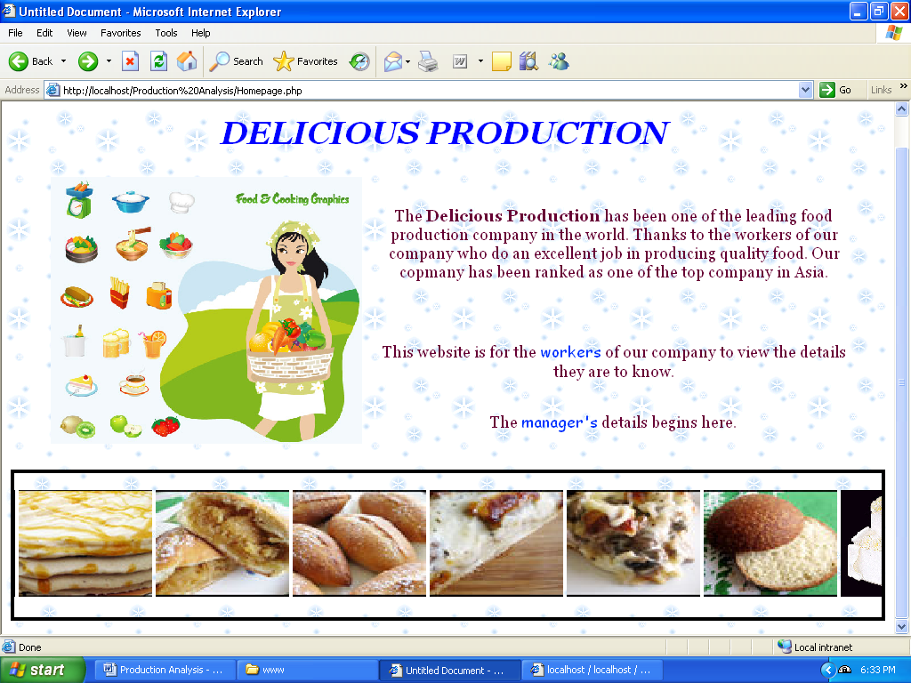

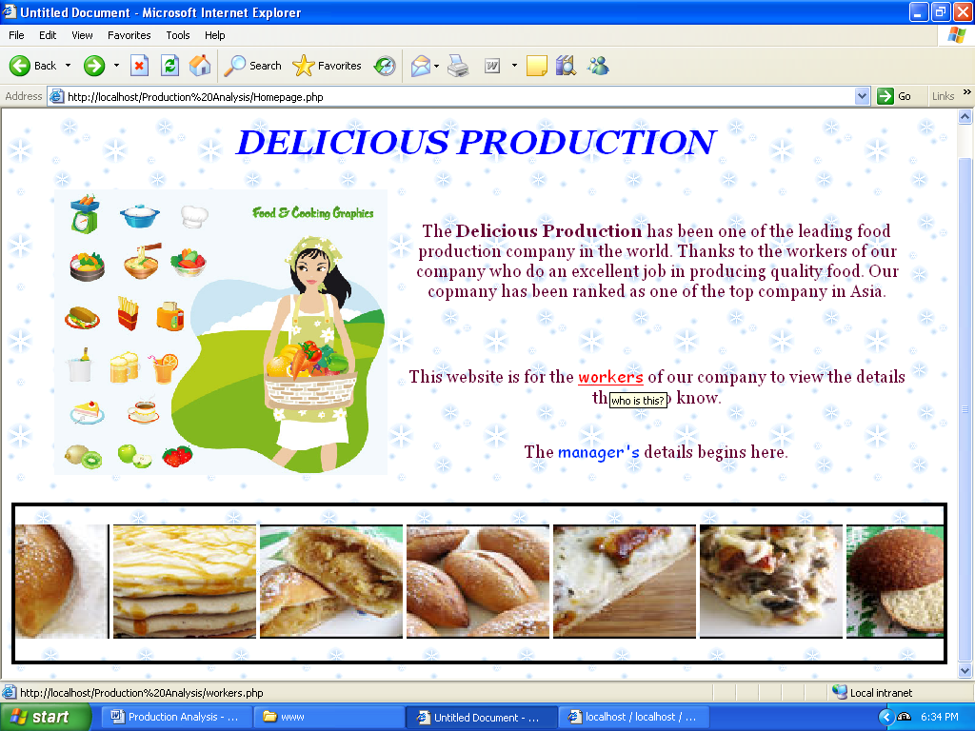

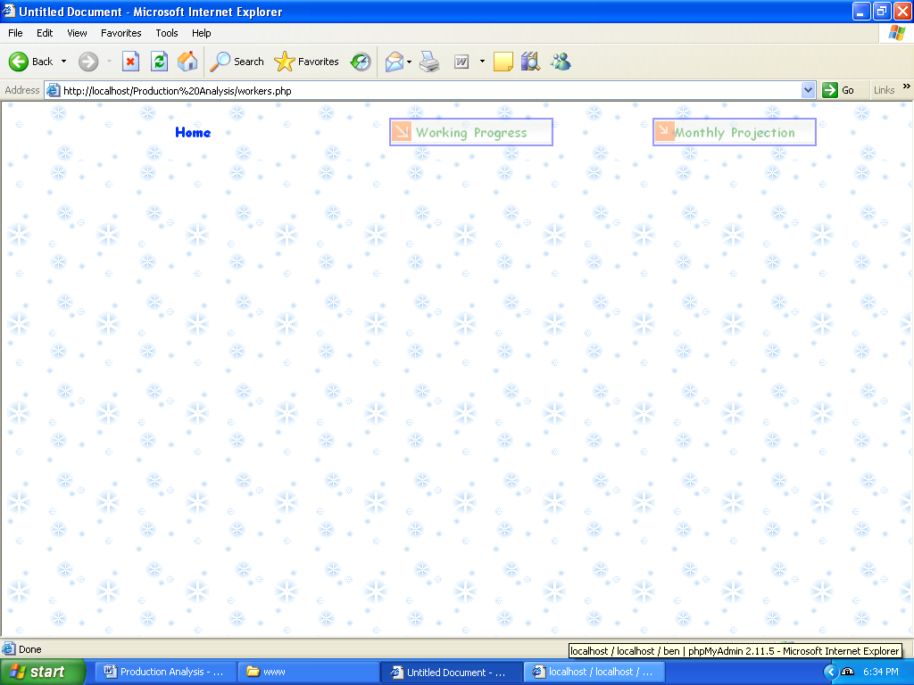

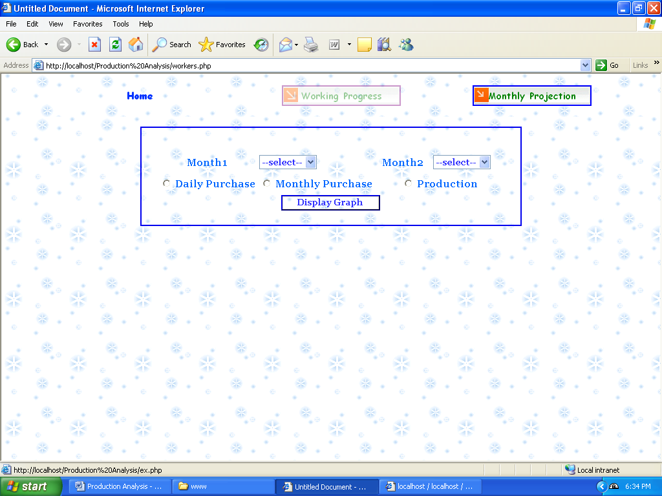

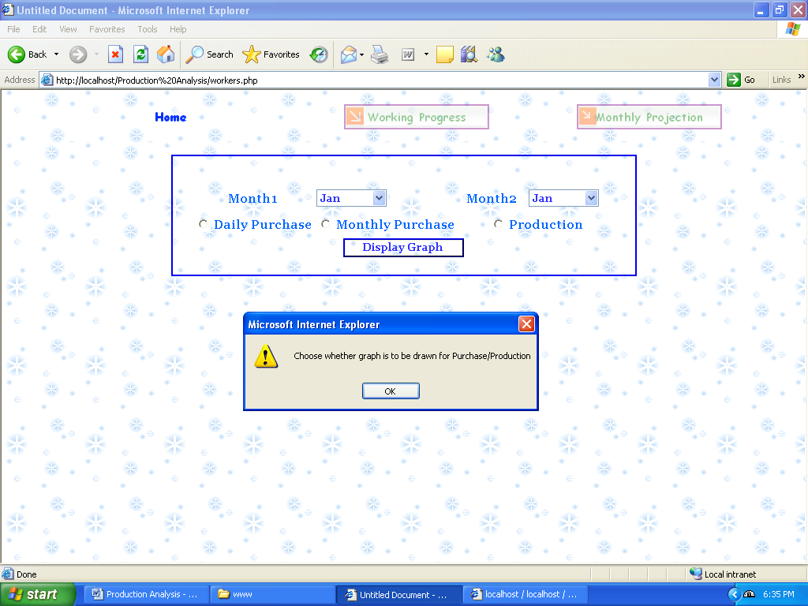

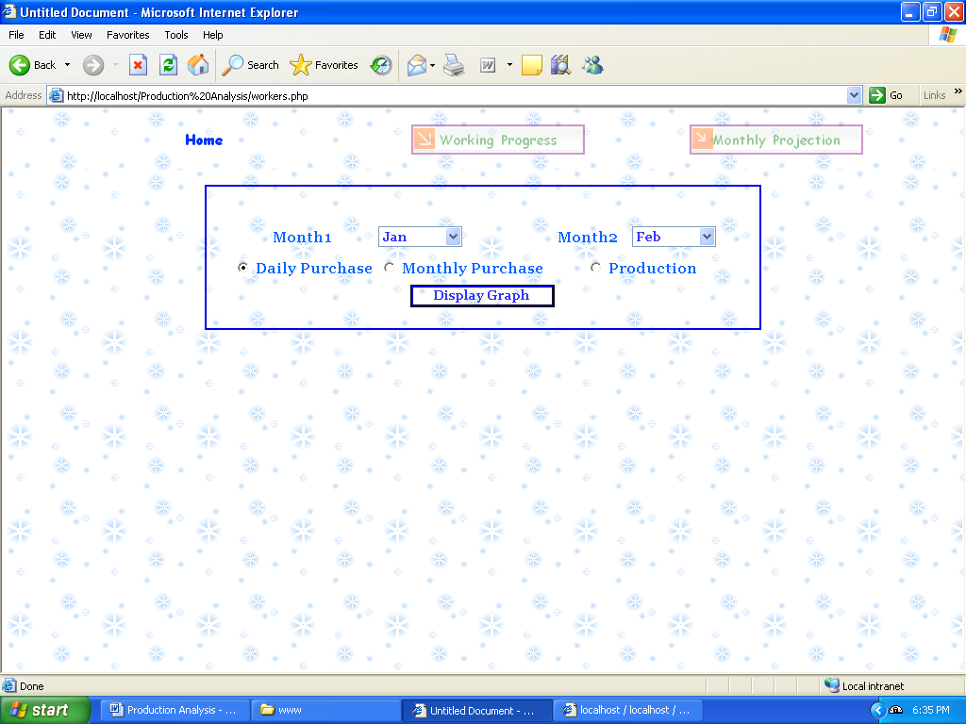

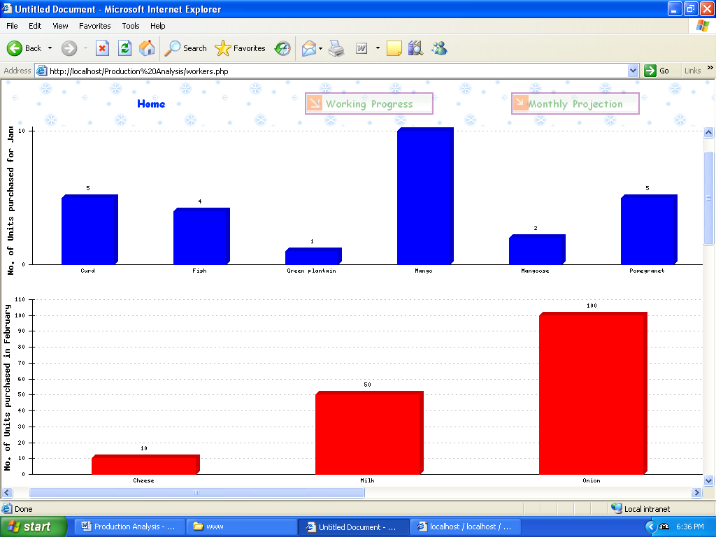

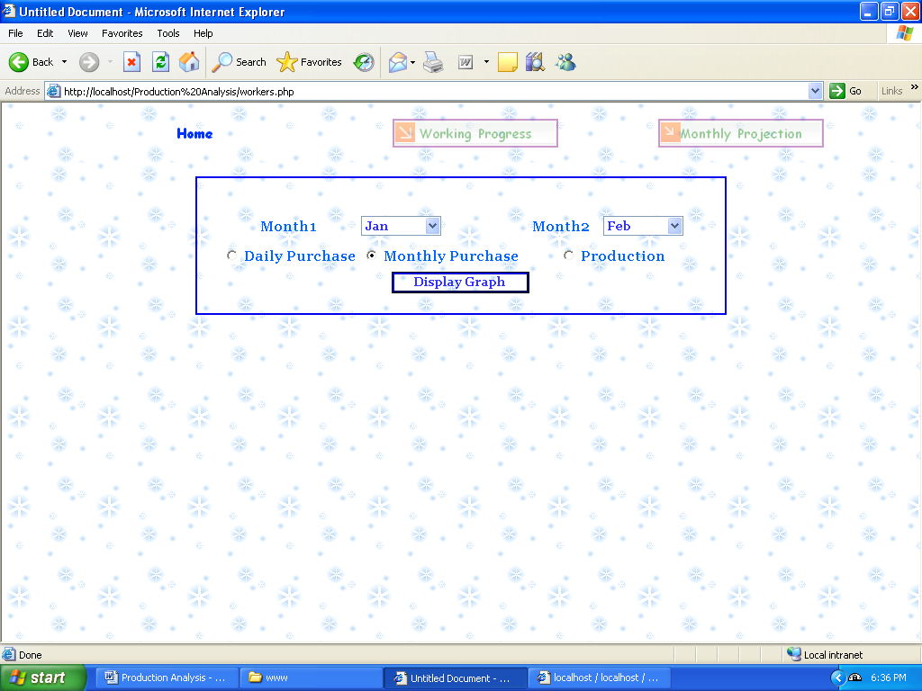

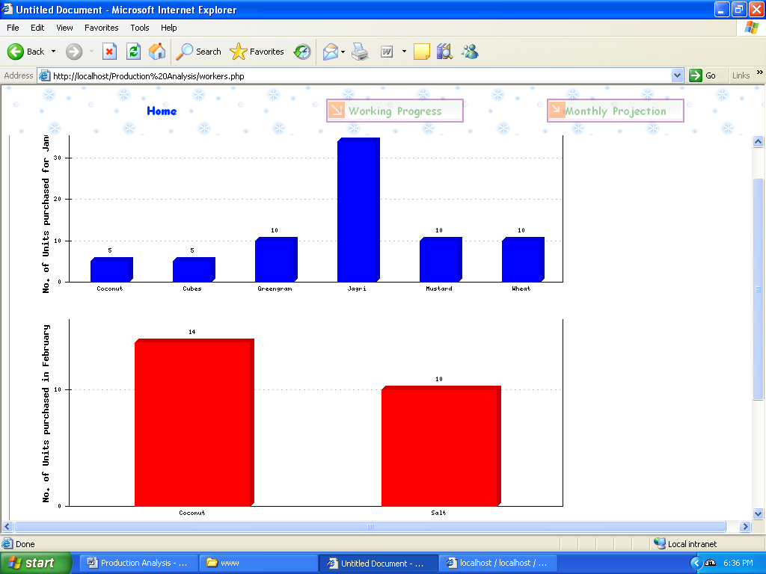

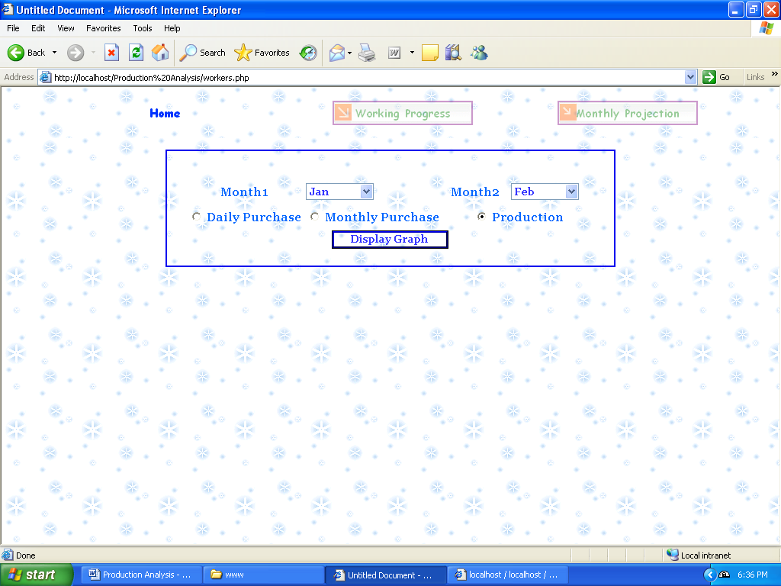

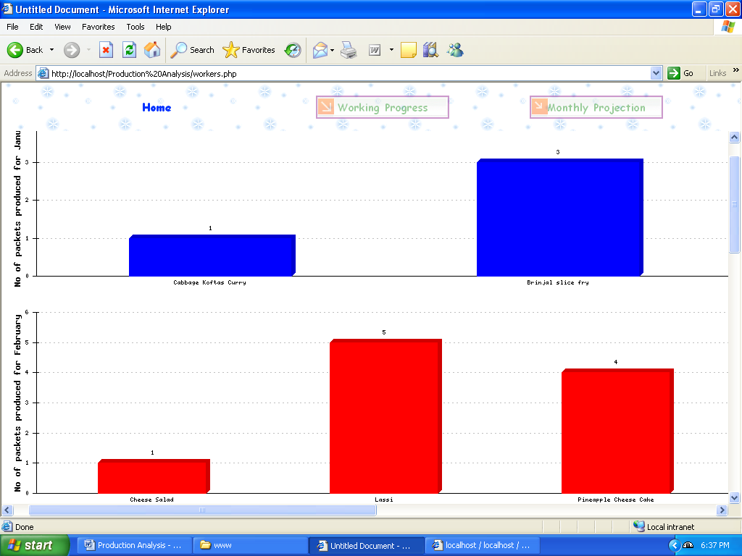
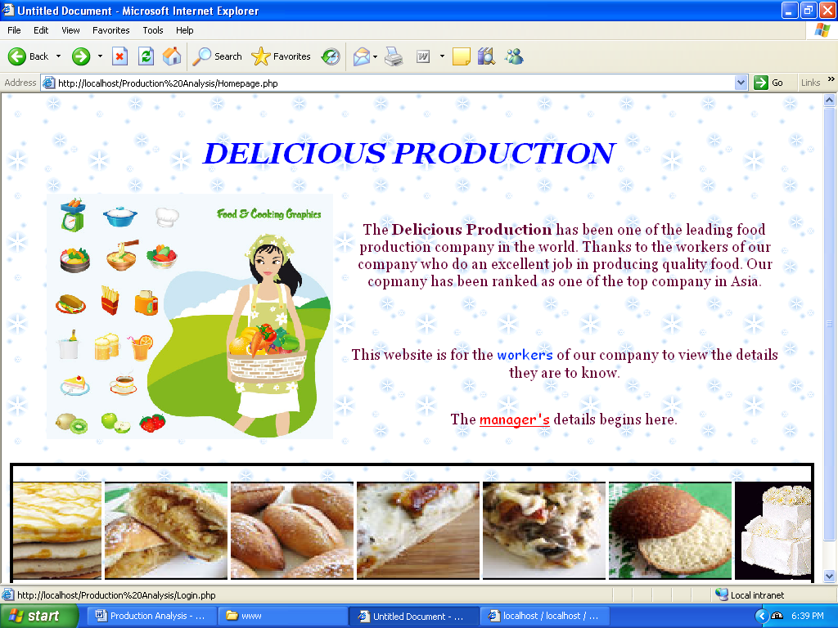

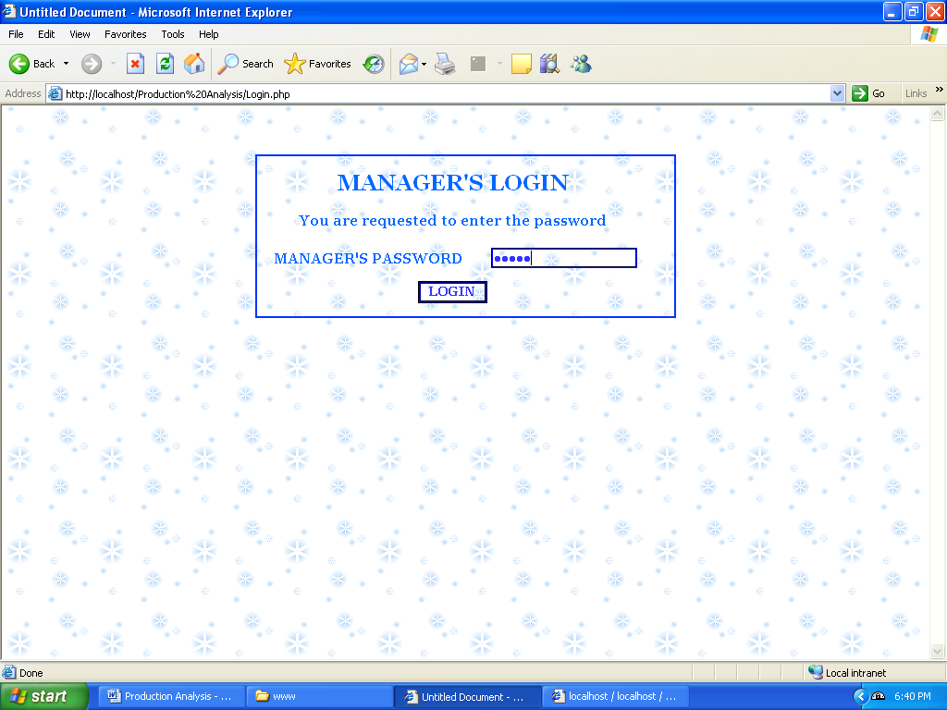

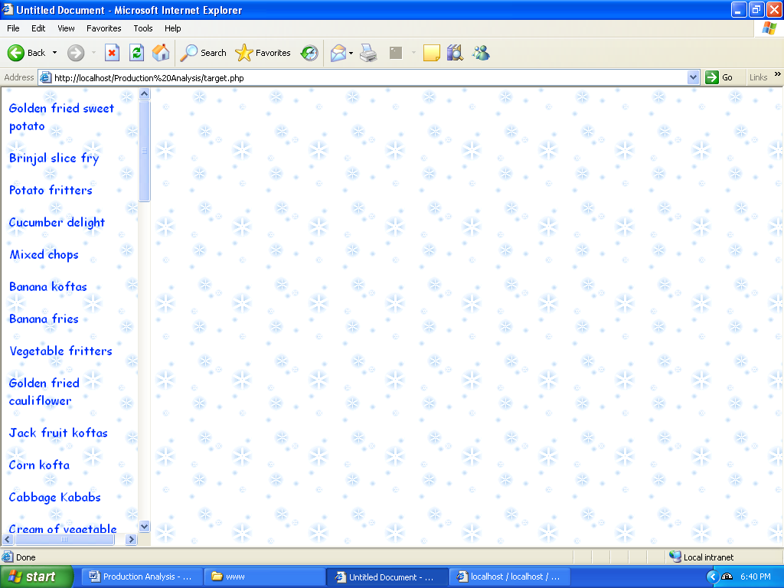

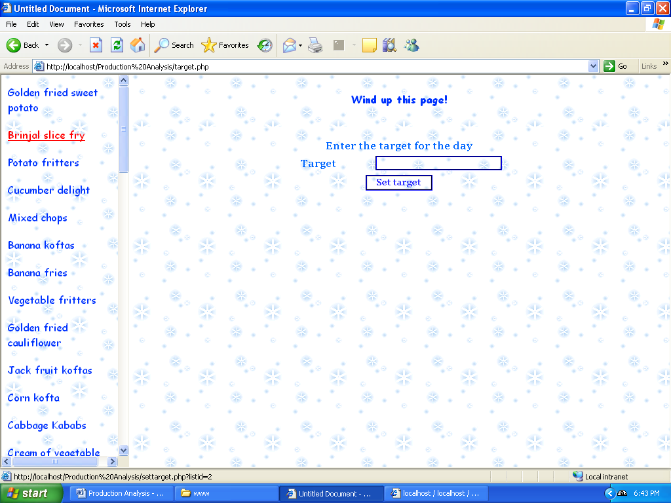

USER MANUAL

INSTRUCTIONS FOR THE DEVELOPER

- Save all the programs that make up the web application in a folder named ‘Production Analysis’ and place the folder in C:\wamp\www directory in a system connected to a local network. This system is the Web server for the web application. Note the IP address of the server
- Start up WAMP Server

To run the web application:
- Open a web browser in any system connected to the local network to which the server is connected.
- If the server’s IP address is 192.168.1.121, then type the following in the URL of the browser:
http://192.168.1.121/Production Analysis/Homepage.php
- The browser opens a web page containing the home page of the application with which the user can proceed.

